Safety Alert
Cone Crusher Adjustment (ram cylinder) Incident

Details of the Incident
A quarry operative suffered a crushing injury to his right hand (little finger) when working with a colleague. The two men, who were undertaking planned maintenance, were given the task of adjusting (closing) a cone crusher concave setting. The adjustment system was in accordance with the manufacturer’s design, requiring an operative to stand in close proximity to an energised hydraulic system, and to manually handle the piston rod end, whilst it was being operated by a colleague who was positioned a short distance away. The whole task relied upon clear communication between the two men. The crushing hazard when the ram piston was extended or retracted hadn’t been fully appreciated.
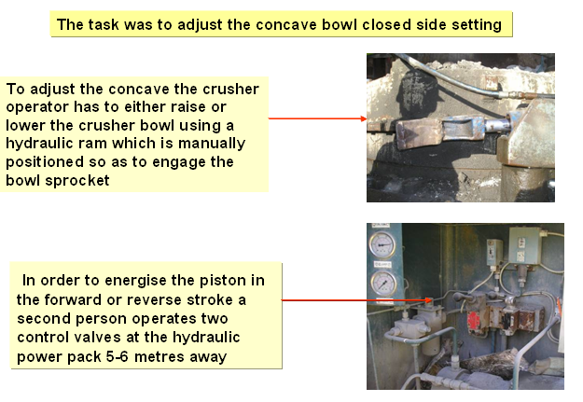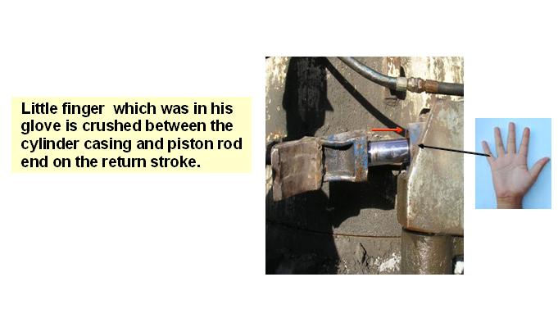
Learning Points
Do you ensure each maintenance task is subject to a suitable and sufficient risk assessment? Each risk assessment should be reviewed following any changes of process, equipment, or personnel. Every risk assessment carried out should be proportionate to the hazards identified and risk factors involved. Any remaining risk identified should be made safe through the introduction of further control measures, safe systems of work, training and supervision. Specifically we should all:-
- Consider similar scenarios across the full range of maintenance tasks which exist, and conduct risk assessments or where appropriate review existing risk assessments.
- Ensure that safe systems of work are in place based upon the hierarchy of safeguarding to determine the best method of preventing access to dangerous moving parts.
- Review the PPE risk assessment for maintenance tasks, dependant on the hazards identified.
- Ensure that everyone is aware that pre-job risk assessment is essential for non routine maintenance tasks such as this.
- Carry out recorded Injury prevention tours regularly during maintenance activities.
- Do not always accept historic systems of working as the safest.
- Encourage the use of near miss hazard alert reports to identify unsafe conditions.
- Where a Safe System of Work requires communication between two or more parties ensure that it is effective by considering verbal and visual limitations. Can the parties hear each other? Can they see each other? Can the risk be reduced by changing the method of work so that a single person is in control?

